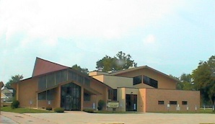

Church Email
sbcriorg@gmail.com

Church Website
www.sbcri.org

Address
919 Sixth Avenue
Rock Island, IL
61201

Phone
309 788-0677

Fax
309 788-5028

Chairman of Deacon
Ministry
Ramar Scales

Treasurer
&
Church Clerk
Patricia Finch

Chairman of Trustee
Ministry
Hewell Colvin

March 18, 2020

Greetings in the Name of our Blessed Redeemer Jesus Christ!

We want to encourage members of the SBC to remain prayerful during
these difficult times. We have readjusted all church activities in light
of the information received about the Coronavirus Disease (COVID-19).

All church services, meetings and other activities have been suspended. This has been since Monday, March 16 and will be in effect through Saturday, April 11.

We will be having a modified Sunday worship services, March 22, 29 and April 5, that will be live streamed online. Our Sunday Church Service can be viewed on Facebook Live. (Please note: You do not need a Facebook account to view our live stream broadcasts). Go to our church website at www.sbcri.org and look for the link at the top of the webpage to find the live stream broadcast of our worship service at 10:00 a.m. If you cannot join the live broadcast, you will be able to access the recordings via the “Video Archives” link also found on our church website. If you don’t know how to do this, ask a Grandchild.

Don’t forget your tithes and offerings. You can use our Online Giving Tool, by visiting our website at www.sbcri.org. You can also mail or put it into the postal mail drop box, located outside the FLC Entrance Doors.

Please continue to be safe and prayerful of our community and the nation.

Yours in the love of Christ,

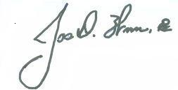
Pastor Joseph D Williamson, III
Second Baptist Church, Rock Island

